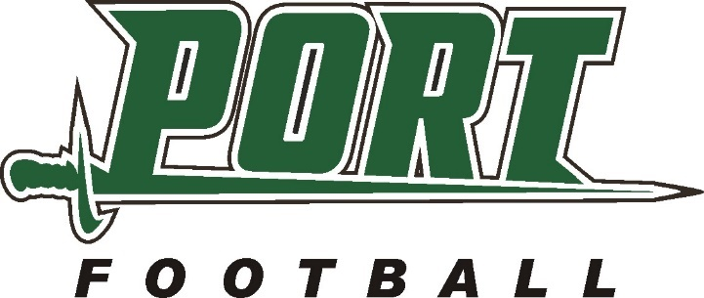
Port Pirates Annual
Water Softener Salt Fundraiser

Tired of lifting your own Water Softener Salt?
Let the PWHS Football Team deliver it to your home or business!

The Port Washington H.S. football team will be delivering water softener salt to homes and businesses in the Saukville-Port Washington area to raise funds for Port Football Programs. 50% of your purchase will go directly to Port Washington Youth Football Programs.

How: Complete the order form below and mail with your check by May 6th or you may
order online at: www.portgridironclub.com
When: Salt will be delivered on May 13th (residential orders), between 10:00 AM and 4:00 PM
Large business orders will be delivered, Friday May 12th, during business hours.

What: Cargill Diamond Crystal Solar Salt Extra Coarse
“Up to 99.6% pure salt *Low insoluble content *White, opaque appearance *High-purity salt, evaporated naturally by the sun and wind *Recommended for use in all side-by-side water conditioning units *Minimizes accumulation of brine tank residue *Crystals resist mushing and
bridging

Cost: $8.00 per 40 lb. bag (5 Bag Minimum Order – Thank You)

Cut along the dotted line and mail with check by April 30th.
--------------------------------------------------------------------------------------------------------------------------
Please deliver 5 bags @ $8.00 per bag / Enclosed check amount

Name: Phone:
Street: City:
Email:
Special Delivery Instructions (Ex.-North side of garage, leave on porch)
Sold by:
Make checks payable to and send to:
Port Gridiron Club
PO Box 134
Port Washington, WI 53074
THANK YOU FOR YOUR SUPPORT!!
Direct questions to:
John Bunyan- 262-268-5595

